Test Case 1 - BMSM
Create BMSM promotion [PROMO_485]
Cus group: sleeping_customer
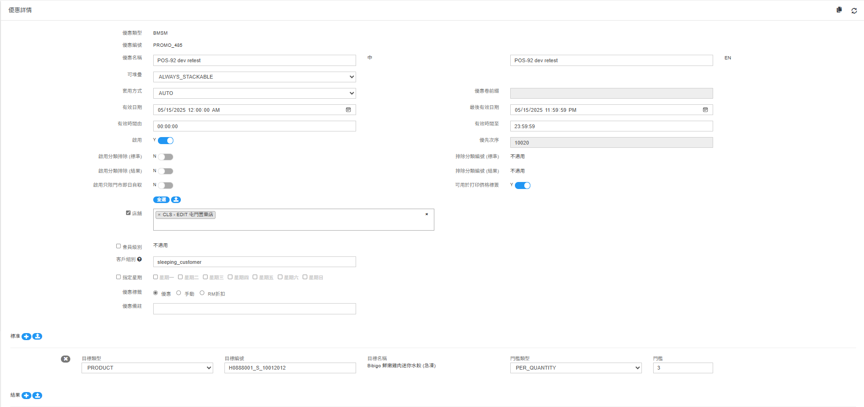
1.1 Testing Customer: 62086677 (sleeping_customer)
Result: Applied promotion as expected
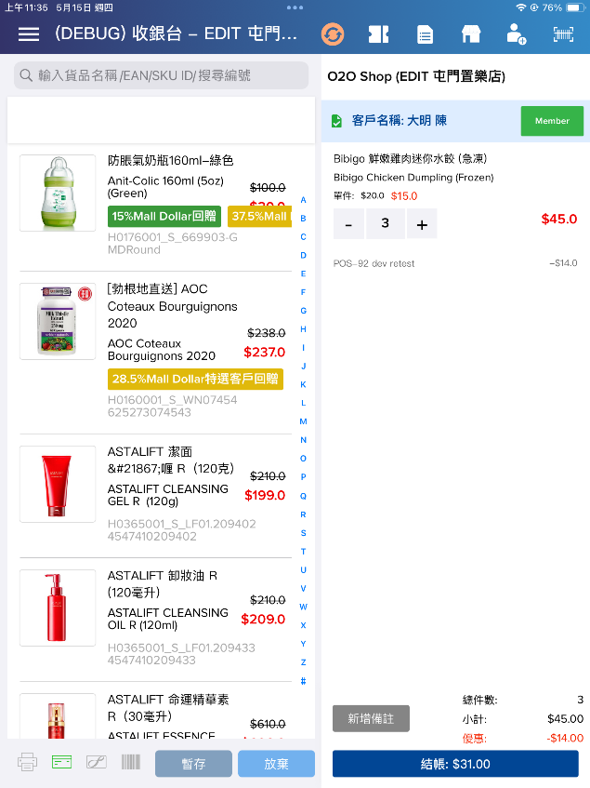
1.2 Testing Customer: 93456789 (VIONLY_group)
Result: Didn’t apply promotion as expected
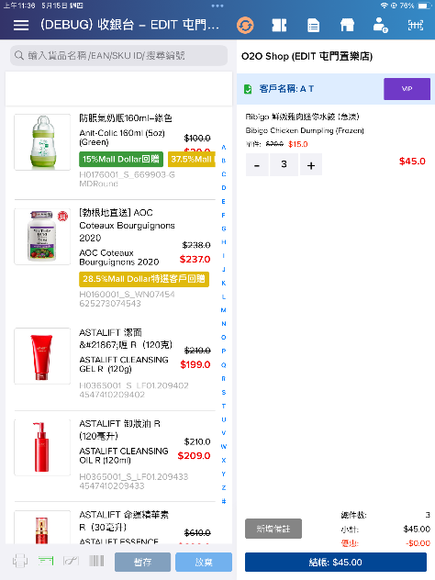
1.3 Testing Customer: non-member
Result: Didn’t apply promotion as expected
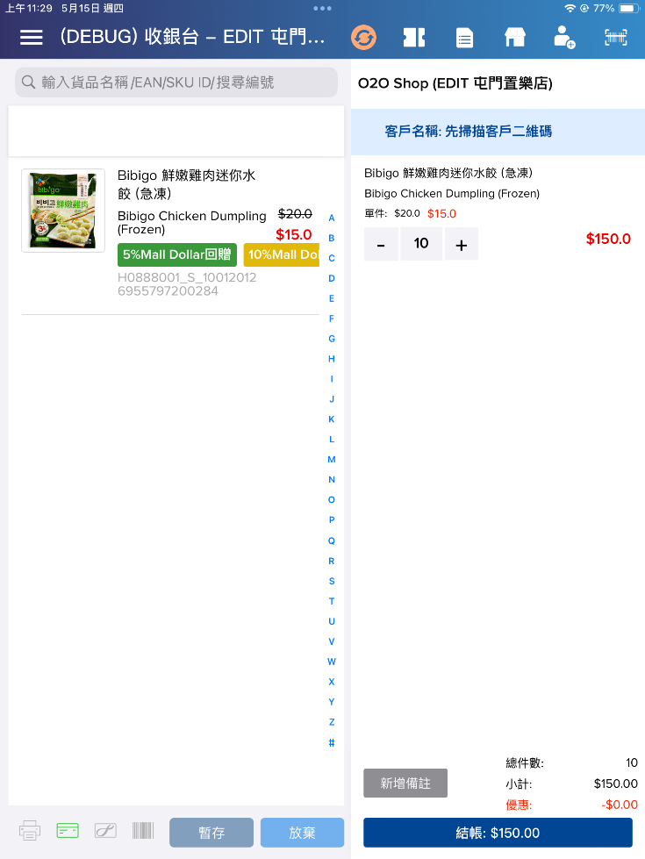
Test Case 2 - Coupon
Create Coupon promotion [PROMO_486]
Cus group: sleeping_customer
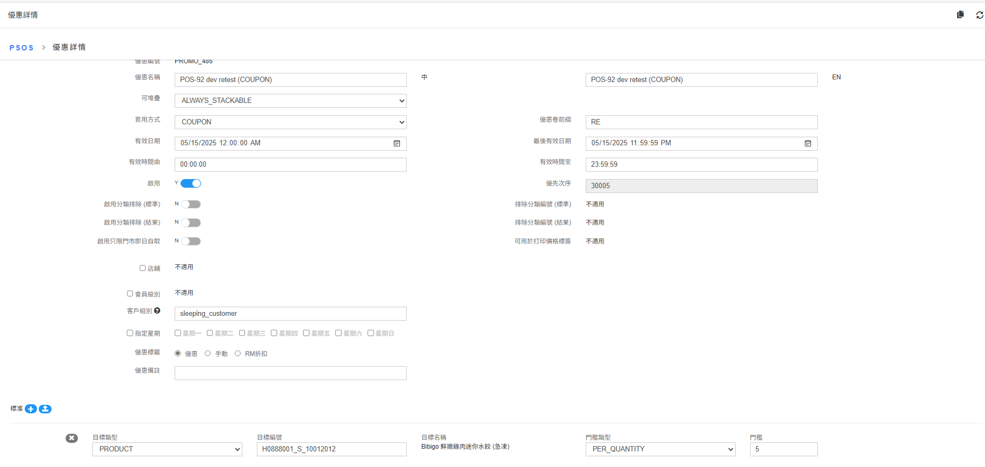
Coupon – RE_001

2.1 Testing Customer: 62086677 (sleeping_customer)
Purchase 5 qty target product to fulfill coupon promotion
Result: Applied promotion as expected (已符合)
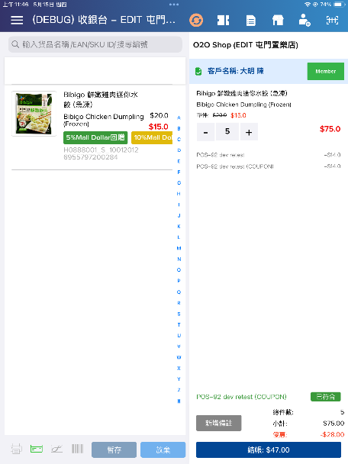
2.2 Testing Customer: 62086677 (sleeping_customer)
Purchase 4 qty target product, which cannot fulfill coupon promotion
Result: Didn’t apply promotion as expected (未符合)
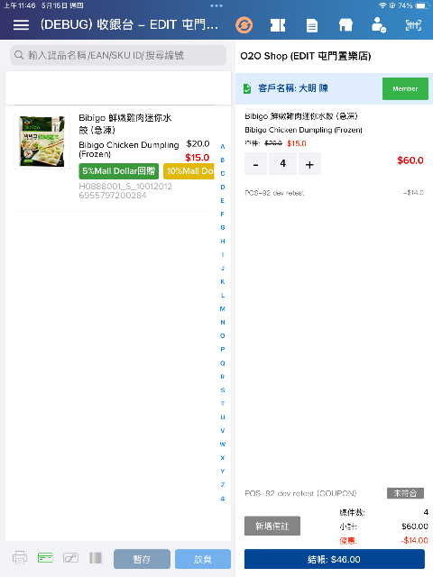
2.3 Testing Customer: 93456789 (VIONLY_group)
Result: Didn’t apply promotion as expected (未符合)
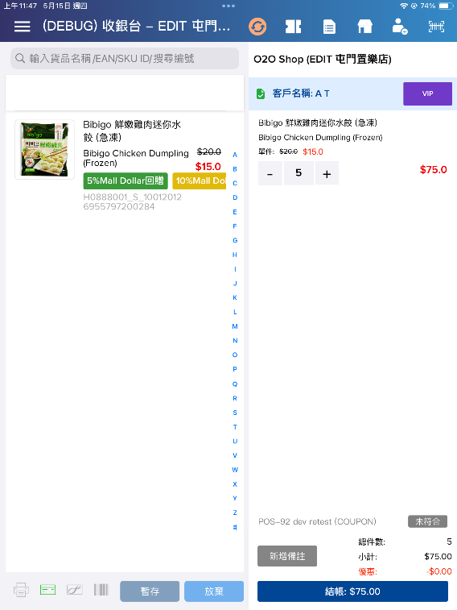

2.4 Testing Customer: non-member
Result: Didn’t apply promotion as expected (未符合)
